**San Francisco State University  
CSC 648 - 848  
Milestone 0 Submission Form  
Section 04 Team 02**

**Tech Stack -**

**Server Host:** Amazon AWS

**Operating System:** Ubuntu 22.0

**Database:**MySQL 8.0

**Web Server:**Nginx 1.20.1

**Server-Side Language:** Python 3.11

**Web Application Framework:**React 18.2.0

**Server Application Framework:**Django 4.1.6

**IDE:**Visual Studio Code, PyCharm

**Website URL**: http://13.52.61.95/  
**SSH URL:** ec2-13-52-61-95.us-west-1.compute.amazonaws.com  
**Database URL:** testdb.cf8asksiuwjo.us-west-1.rds.amazonaws.com

**Database Username:** admin  
**Database Password:** rainbow77

**Familiarity:**

|  |  |  |  |  |  |
| --- | --- | --- | --- | --- | --- |
| **Student Name** | **React** | **Python** | **MySQL** | **Amazon AWS** | **Django** |
| Ashmitha Dale Pais | 2 | 3 | 4 | 2 | 1 |
| Steve Betts | 1 | 4 | 4 | 1 | 4 |
| Chris Farnsworth | 1 | 4 | 3 | 1 | 3 |
| Abdul Barrie | 3 | 2 | 1 | 1 | 1 |
| Preet Dhaliwal | 1 | 2 | 4 | 1 | 2 |
| Nathan Loo | 2 | 3 | 1 | 1 | 1 |

**Study Plan:**

Amazon AWS, Amazon RDS, MySQL - Ashmitha Pais

Django, Python, MySQL - Steve, Preet, Chris

React, MySQL - Nathan and Abdul

Database, Git issues - Preet

**How to connect to EC2 instance:**

1. Clone **https://github.com/CSC-648-SFSU/csc648-spring23-04-team02**
2. Run “**cd csc648-spring23-04-team02/Application_SE02**”
3. Run “**ssh -i "mykey.pem" ubuntu@ec2-13-52-61-95.us-west-1.compute.amazonaws.com”**
4. It will connect to the EC2 instance, change permissions of mykey.pem to 400 if you see permission errors.

**For database creation:**

Created a free tier database from Amazon RDS with the following configurations:

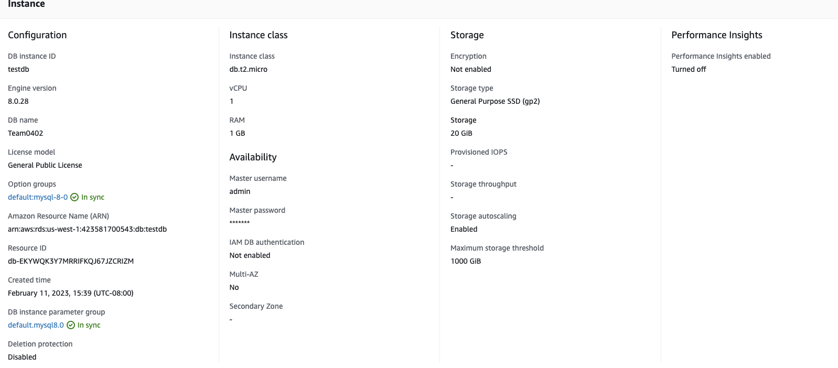

2. Used [MySQL workbench](https://dev.mysql.com/downloads/workbench/) to access the amazon RDS database.

**For creating EC2 instance:**

1. We created a free tier EC2 instance. It is a t2.micro instance with 8gb memory.
2. Next, we used docker and docker compose to generate the build and get our code up and running on the instance.



**For hosting onto EC2 after changes:**

1. Create a feature branch from the main branch and make changes. Pushed code to your branch.
2. Raise a review from feature branch to main branch. Get it approved by Front-End Lead, Back-End Lead, Scrum Master and Team Lead.
3. Once the branch is merged, the Team Lead pulls from the repo, create a new npm build using **npm run build** and then hosts it on ec2 and builds it using **docker-compose up –build.**